Weather “Triple-Play” Project
Part 1: Three-Day Weather Map
You will first need to decide on a season and month that you would like to show on your weather map. Keep in mind the month and season you are showing on your map. The weather should relate. For example you would not show snow in Seattle if your season was summer and the month you selected was July and you might show a hurricane in Miami if the season you selected was autumn and the month was October. Choose from below. Circle, color, or highlight your selections.
Spring | Summer | Autumn | Winter
March | June | September | December
April | July | October | January
May | August | November | February

- You will create a three-day weather map showing the Lower 48 United States. Use the maps that have been provided and staple to your final project. Your weather maps must include FOUR cities. The choice of city is up to you but needs to come from one of the columns below and represent a city from each (Western US, Central US, Eastern US). In addition, your fourth choice will be Charlotte, NC. Each city will be shown on the map each day. Choose from below. Circle, color, or highlight your selections.
Western US | Central US | Eastern US | Charlotte, NC
Seattle, WA | Dallas, TX | New York, NY
San Diego, CA | Denver, CO | Cleveland, OH
Reno, NV | Chicago, IL | Atlanta, GA
Salt Lake City, UT | Kansas City, MO | Miami, FL

- Next to each city on each day you will need to show these three pieces of information.
Low Temperature | High Temperature | Picture of the dominant weather for the day (sun, rain, snow, wind, cloudy, etc.)

- For each day of your weather map you will need to show at least three types of weather fronts. These fronts will not necessarily be the same each day and should change depending on how the weather fronts are moving across the country and interacting with other air masses along the way. Accurately show the weather front and symbol for each type of front shown on your map. The four types of fronts are listed below. Check your notes for symbols.
Cold Front | Warm Front | Stationary Front | Occluded Front

Part 2: Three-Day Weather Forecast
You will create a three-day weather forecast for each city such as the examples shown below. You may use the template provided, a hand-drawn template, or a digital template that has been printed out. Attach the four forecasts to your final project. Your forecast must include the city and day of the week but you may choose any three pieces of information to add including:
High/Low temperature | Picture of the dominant weather of the day | Percent chance of precipitation
Name/symbol of the weather front affecting the days weather | Wind speed and direction | Description of the weather (cloudy morning with sun in the afternoon, etc.)

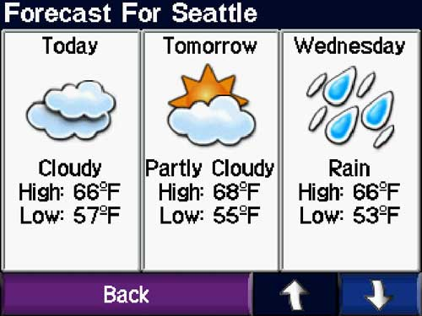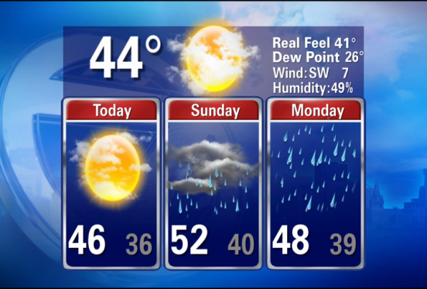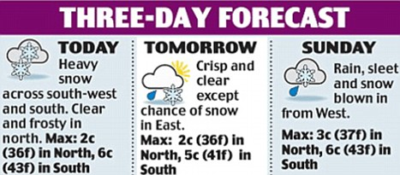
Part 3: Three-Day Weather Narrative
You will create a three-day weather narrative for TWO of the cities you selected. Your narrative should tell a story of a person that is living or visiting the cities you selected. You will have TWO narrative stories and will attach them to your final project. This is a free-writing exercise so feel free to be imaginative and creative in the activities and descriptions. You need to mention three ways the weather influenced the actions of the person in your narrative on each day. (It started raining when we left the movie theater, It was warm and sunny when we went to the beach, we were sucked up in a swirling tornado created by a thunderstorm that was created when the cold front came through Texas, etc.). Three sentences minimum in each of the three times of day; morning, afternoon, and evening.
Example: City________________________Day___________________(X 3)
Morning: description of weather and its effects on daily activities (three sentences minimum)
Afternoon: description of weather and its effects on daily activities (three sentences minimum)
Evening: description of weather and its effects on daily activities (three sentences minimum)
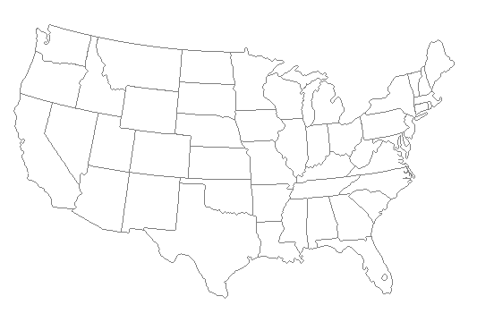
Three-day Weather Forecast For: _____________________
Day: | Day: | Day:

