Weather Map Practice Name_________ _____
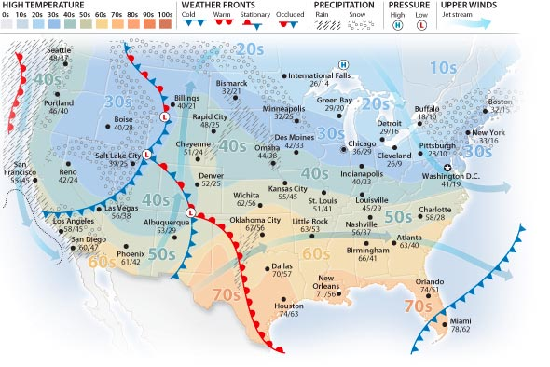
Use the weather map above to answer the following questions:
- The map shows a series of fronts moving across the USA. What type of front is not shown on the map?
- A “low pressure” system is moving east towards Cheyenne, Wyoming. Name two ways that this area of low pressure will affect the weather their tomorrow?

- What type of weather front is moving towards Dallas?
- What will happen to the temperature in Miami tomorrow as the front that is moving south passes through today?
- A warm front like the one moving towards Washington and Oregon will likely bring extended periods of rain. True or False.
- It is not shown on the map but you could infer that what kind of pressure in place over Orlando, FL. High Pressure or Low Pressure.
- Winds moving across Louisiana, Alabama and Mississippi are moving from _____________(direction) to ____________(direction)
Weather Map Practice Name_________ _____
Use the weather map above to answer the following questions:
- The map shows a series of fronts moving across the USA. What type of front is not shown on the map?
- A “low pressure” system is moving east towards Cheyenne, Wyoming. Name two ways that this area of low pressure will affect the weather their tomorrow?

- What type of weather front is moving towards Dallas?
- What will happen to the temperature in Miami tomorrow as the front that is moving south passes through today?
- A warm front like the one moving towards Washington and Oregon will likely bring extended periods of rain. True or False.
- It is not shown on the map but you could infer that what kind of pressure in place over Orlando, FL. High Pressure or Low Pressure.
- Winds moving across Louisiana, Alabama and Mississippi are moving from _____________(direction) to ____________(direction)

