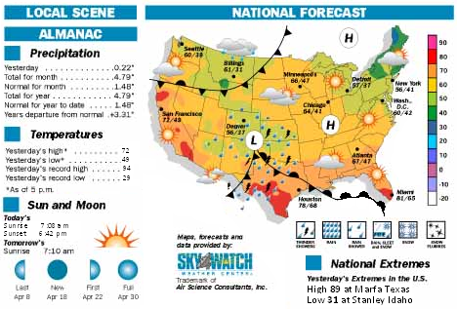

Use the weather to answer each question
1. What time did the sun rise today? ___________ What time will the sun set tonight? ____________

2. What is the temperature difference between yesterday’s high and low temperatures? _______________degrees

3. What type of front moved through Stanley, ID to make it the lowest temperature in the country yesterday?_________

4. By looking at the precipitation data has it been a wet or dry month compared to the monthly average?_____________

5. By looking at the map I can infer that map is showing the forecast for what month of the year?___________________

6. What symbol is used for high pressure? ________

7. List a city that are close to a low pressure center?

8. What type of weather is associated with a low pressure area?

9. What type of front is affecting today’s weather (according to the map) in Belton Texas?

10. Use the map to write a weather forecast for your area tomorrow.

