If a section is highlighted, it needs your attention. Do not turn in your lab with anything highlighted!

Name

1. Title-Speed and Velocity Lab

2. Purpose-The purpose of this experiment is to measure average speed, observe the difference between instantaneous and average speed, represent velocity with vectors, and determine how to make paper attain the highest average speed possible.

Questions:
- How can you make one sheet of paper attain the highest average velocity?

3. Hypothesis (predictions)
-I predict that…
4. Materials:
- Paper Ball, Paper Triangle
- 2 Blank Sheets of Paper (to create your own airplane models)
- Rubber Band
- Stopwatch (or phone with Stopwatch feature)
- Meter Stick
- Masking Tape

5 Procedure
- Start with the object listed in the trial. Create a starting Point and mark with masking tape.
- You will create three trials of each method of launch.
- At each trial, on team member will launch the object, while another will time the length of the launch.
- The third team member will measure the distance using meters. If the measurement is less than a meter, do not convert to centimeters. Use decimals to show the precision of each trial. Do not forget to indicate the vector (or direction) of each trial.
- Calculate the average velocity of each trial.

5. Data Table

Means of Launch | Trial | Distance (m) | Time Traveled (s) | Average Velocity (m/s) | Vector (direction)
1. Throw  (Paper Ball) | a.
 | b.
 | c.
AVERAGE SPEED OF THROW
2. Kick  (Paper Ball) | a.
 | b.
 | c.
AVERAGE SPEED OF KICKS
3. Flick  (Paper Triangle) | a.
 | b.
 | c.
AVERAGE SPEED OF FLICKS
4. Rubber Band Slingslot  (Paper Triangle) | a.
 | b.
 | c.
AVERAGE SPEED OF SLINGSHOT
5. Paper Airplane  (Model #1) | a.
 | b.
 | c.
AVERAGE SPEED OF MODEL #1
6.Paper Airplane (Model #2) | a.
 | b.
 | c.
AVERAGE SPEED OF MODEL #2

Observations-Make your own observations about the motion of the paper. The more the better. Be sure to include observations about instantaneous speed/velocity vs. average speed/velocity. (Take Notes Below)

6. Results. Begin by highlighting all of the average speeds for your trials. You will then create a bar chart comparing each trial below. Please color code each trial a different color for ease of analysis.

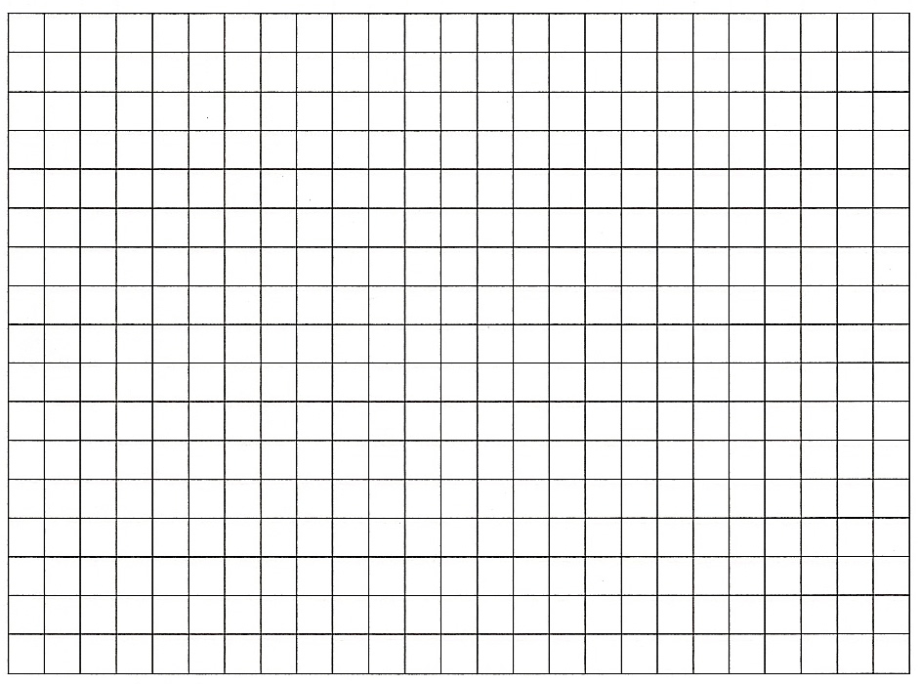

Trials

7. Conclusion- Please write an analysis of each object below, comparing and contrasting their motion and velocity.

