Science Review Packet
The end of the year is fast approaching!! We have the cumulative science test coming our way and I wanted to make sure you had a way to. This packet will be very helpful.
Important Dates:
- June 1st – Science NCFE (similar to an EOG for science – for the state)
Included in this packet is:
- All vocabulary words from each quarter
- Other topics you should be comfortable with from past units
- Practice Pages

What to know about Weather
- What are the four main layers of the atmosphere? How does the temperature change with each one? What happens in each one?
- How do warm and cold front work?
- How do tornadoes form?
- How do hurricanes form?
- How do thunderstorms form?
- What is the water cycle?
- Explain what high and low pressure systems are and the type of weather found at each.
- Explain how wind moves.
- Explain the symbols on the weather map (cold front, warm front, stationary front, high and low pressure).
- What are the three main types of clouds, what is their shape, and what elevation are they generally found at?
- What is convection and how does it impact weather?
- How do global winds generally blow and why?
- What is the jet stream?
- Explain the ways in which humans can positively and negatively impact our atmosphere.

What to know about Cells and Human Body
- Explain how the euglena, paramecium, amoeba, and volvox move and how they obtain food.
- Explain the purpose of the major organelles including:
  - Cell wall, cell membrane, cytoplasm, mitochondria, chloroplast, vacuole, and nucleus
- Understand that
- Explain the function of the body’s main systems as well as major organs in each:
  - Skeletal, muscular, circulatory, respiratory, digestive, urinary, and nervous
- Explain how the above systems interact with one another to help us maintain homeostasis.

What to know about Genetics
- In detail, explain why asexual reproduction gives less variation than sexual reproduction.
- What is mitosis?
- What is meiosis?
- What are examples of asexual reproduction?
- Use a Punnett Square to predict the offspring of parents.
- Use a pedigree to trace a genetic trait through a family tree.
- Explain how environment and lifestyle choices can influence genetic variation.

What to know about Physics
- Explain how to calculate speed with the given equation.
- Explain how friction affects the movement of an object.
- Show how to plot speed on a graph.
- Show how to read speed off of a graph already given to you.
- What are Newton’s Three Laws?
- Explain what kinetic and potential energy are.
- Explain how kinetic and potential energy can change between one another.
- Explain the Law of Conservation of Energy.
- Explain how simple machines (levers, inclined planes, screw, wedge, wheel and axle) can make jobs easier.

Weather Vocabulary
Hypothesis: follows an observation or experience, is created in order to tentatively predict the outcome of a scientifically designed test
Density: the ratio of mass to volume (m/v) in any type of matter.
Altitude: the distance above sea level when discussing the atmosphere.
Atmosphere: the layer of gases around a large body in space, such as a planet or star.
Troposphere: where weather and life occur, the ground heats the atmosphere gases so the temperature decreases as you move upward through the layer.
Stratosphere: just above the troposphere; planes fly here. Gets warmer as you go up through it.
Mesosphere: just above the stratosphere; gets colder as you go up through it. Meteors burn up here.
Thermosphere: just above the mesosphere; the Aurora Borealis occurs here. Gets warmer as you go up through it.
Carbon cycle: the process by which air is inhaled by animals, and then exhaled. It is this gas which plans take in and use in the process of photosynthesis.
Nitrogen cycle – the process by which a particular gas in the air is changed to liquid and solid formsi n the soil by bacteria, it is used by plants and animals and returned to the soil.
Warm Front: a type of front which forms when warmer air pushes a colder air mass. The warmer air rises slowly over the cold air and its moister condenses into flat clouds.
Cold Front: when a cooler air mass pushes a warm air mass and forces the warm air to rise. As the warm air rises, its moisture condenses and forms tall clods.
Stationary Front: the type of front which occurs when two air masses push against each other without moving.
Ultraviolet radiation: Radiation with a higher frequency than visible light. Can cause sunburn and other types of damage.
Infrared radiation: Radiation of lower frequencies than visible light; tends to warm the materials that absorb it.
Conduction: transfer of heat from one object to another through direct contact.
Convection: transfer of heat from place to place by motion of heated gas or liquid.
Radiation: energy that travels across distances as certain types of waves.
Greenhouse effect: an increase in the surface temperature of a planet caused by the absorption and emitting of infrared radiation by certain gases. In Earth’s case it is CO2.
Ozone: Made of three oxygen atoms, created and destroyed in the stratosphere; heats our atmosphere, while absorbing dangerous ultraviolet radiation.
Cells and Human Body Vocabulary
Homeostasis – the process which a living organism maintains a balanced internal environment to stay alive
Unicellular – made up of one single cell
Multicellular – made up of many cells
Cell membrane – forms the flexible outer boundary of the cell, only allows certain materials to move into or out of the cell
Cytoplasm – a gel like material inside the cell, it contains water and nutrients for the cell
Nucleus – directs the activity of the cell, it contains chromosomes with DNA
Mitochondria – breaks down food and releases energy to the cell
Vacuole – storage areas for the cell
Cell Wall – provides structure to plant cells
Chloroplast – contains chlorophyll that is used to make food for the cell
Function – the activity something is responsible for; a role; its purpose
Structure – the way in which parts are shaped or arranged
Levels of organization – the ideas that living things are organized in the following order: cell, tissue, organ, organ system, organism
Skeletal System – the body system responsible for support and protection
Muscular System – the body system responsible for movement; uses a series of contractions and releases to move
Circulatory System – the body system responsible for moving blood rich in nutrients and oxygen around the body and returning it to the heart
Blood – a fluid in the body which delivers nutrients and oxygen to the body as well as removes carbon dioxide and other wastes.
Blood vessels – the series of tubes within the body which transport for our circulatory system
Digestive System – the body system responsible for breaking down food into fuel for our body to use as energy and excreting waste from this process
Respiratory System – the body system responsible for the intake of oxygen and the release of carbon dioxide
Lungs – the organ responsible for the exchange of oxygen and carbon dioxide in the body
Endocrine System – the body system responsible for using glands and hormones to regulate processes in the body
Hormone – a chemical that is made in one organ and travels through the body to another organ
Nervous System – the body system responsible for helping your body respond to stimuli and react accordingly
Stimulus – something that causes a response in an organism or part of the body
Genetics Vocabulary
Gene: The basic unit of heredity that consists of a segment of DNA on a chromosome
Heredity: The passing of genes from parent to offspring
Traits: Characteristics that inherited from parent to offspring
DNA: The genetic material found in all living cells
Chromosomes: The physical structure in the cell that contains the cell’s genetic material
Genome: The full DNA sequence of an organism
Mutation: Any change made in DNA
Genetic Engineering: The process used by scientists to intentionally manipulate DNA in order to alter the characteristics of an organism
Down’s Syndrome: A genetic disorder where an additional chromosome number 21 is present in an individual resulting in specific physical and intellectual disabilities
Sickle Cell Disease: A genetic disorder that results in an abnormal red blood cell with a crescent shape
Asexual Reproduction: A type of reproduction in which a single organism produces offspring that have the same genetic material
Sexual Reproduction: A type of reproduction in which male and female reproductive cells combine to form offspring with genetic material from both cells
Mitosis: Cell division resulting in two identical cells
Meiosis: Cell division resulting in four sex cells with half the normal amount of genetic material
Gametes: A sperm or egg cell that contains half the usual number of chromosomes
Phenotype: The characteristics that can be observed
Genotype: The actual genetic makeup of an organism
Allele: A form of a gene for a specific trait
Dominant: The allele that is expressed even if only one copy is present in the genotype
Recessive: The allele that is only expressed if two copies are present in the genotype
Homozygous: The alleles in the genotype are the same
Heterozygous: The alleles in the genotype are different
Punnett Square: A chart used to show the possible ways genes from two parents can combine in order to predict possible genotypes of offspring
Pedigree: A chart that shows family relationships that often includes hereditary indicators of disease and disorders
Environmental Stressors: A factor that may potentially influence an organism’s ability to survive
Physics Vocabulary
Position: An object’s location
Reference Point: A location to which another location is compared.
Motion: A change of position over time
Speed: A measure of how fast something moves through a particular distance over a definite time period.
Velocity: A speed in a specific direction
Vector: A quantity that has both size and direction 3.
Acceleration: The rate at which velocity changes over time
Electrical energy: is energy newly derived from electrical potential energy
Force: A push or a pull; something that changes the motion of an object
Newton’s First Law: A scientific law stating that objects at rest remain at rest, and objects in motion remain in motion with the same velocity, unless acted on by an unbalanced force.
Newton’s Second Law: A scientific law stating that the acceleration of an object increases with increased force and decreased with increased mass.
Newton’s Third Law: A scientific law stating that every time one object exerts a force on another object, the second object exerts a force that is equal in size and opposite in direction back on the first object.
Inertia: The resistance of an object to a change in the speed or the direction of its motion
Centripetal Force: Any force that keeps an object moving in a circle.
Unbalanced Force: Forces that produce a non-zero net force, which changes an object's motion.
Momentum: A measure of mass in motion. The momentum of an object is the product of its mass and velocity.
Collision: A situation in which two objects in close contact exchange energy and momentum.
Friction: A force that resists the motion between two surfaces in contact
Work: The use of force to move an object over a distance
Kinetic Energy: The energy of motion. A moving object has the most kinetic energy at the point where it moves the fastest.
Potential Energy: Stored energy; the energy an object has due to its position, molecular arrangement, or chemical composition.
Mechanical energy: A combination of the kinetic energy and potential energy an object has.
Law of conservation of energy: A law stating that no matter how energy is transferred or transformed, all of the energy is still present in one form or another.
Simple machines: One of the basic machines on which all other mechanical machines are based.
Mechanical Advantage: The number of times a machine multiples the input force; output force divided by input force.

NCFE STUDY GUIDE
Name:
SS Assessment Results:
Unit 1: Weather & Atmosphere
7.E.1.1 Compare the composition, properties and structure of Earth’s atmosphere to include mixtures of gases and differences in temperature and pressure within layers.
- As altitude _________________________, air pressure _____________________________________.
Composition of Earth’s Atmosphere:
- What is the most abundant gas in Earth’s Atmosphere? __________________________________________
Layers of Earth’s Atmosphere:
Layer | Altitude/Density/Temperature | What happens here
Exosphere

Thermosphere

Mesosphere

Stratosphere

Troposphere

As air ____________________, the molecules move _________________________________. When this happens, there is more room for the air to hold ___________________________.
7.E.1.2 Explain how the cycling of water in and out of the atmosphere and atmospheric conditions relate to the weather patterns on earth.
1:
2:
3:
4:
5:
6:
7:
8:
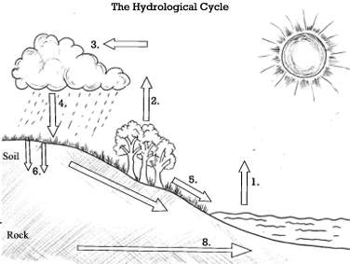
SS Assessment Results:
7.E.1.3 Explain the relationship between the movement of air masses, high and low pressure systems, and frontal boundaries to storms (including thunderstorms, hurricanes, and tornadoes) and other weather conditions that may result.
SS Assessment Results:
What is an Air Mass?
Where do Air Masses get their characteristics?
Air Masses have two letters…one represents ____________ and the other represents _____________________.
HUMIDITY (MOISTURE level): Continental is formed over___________________ and is ____________________. Maritime is formed over ___________________ and is ____________________.
TEMPERATURE: Arctic is formed over________areas. Polar is formed over ________areas. Tropical are formed over ________areas.
mP: | cP:
mT: | cT:

High pressure means a ______________________________________, making the rain and clouds go ______. Low pressure will make you____________________________, because ____________________________ are coming our way!
Compare and Contrast a Tornado and Hurricane

What type of clouds are associated with thunderstorms? ______________________________
7.E.1.4 Predict weather conditions and patterns based on information obtained from: Weather data collected from direct observations and measurement (wind speed and direction, air temperature, humidity and
SS Assessment Results:
air pressure), weather maps, satellites and radar, and cloud shapes and types and associated elevation.
Front | On a Map: | What’s Happening: | Characterized by:
Warm

Cold

Stationary

Occluded

7.E.1.5 Explain the influence of convection, global winds and the jet stream on weather and climatic conditions.
SS Assessment Results:
As air warms, the ____________________________ move _______________________ apart.
This causes a difference in air pressure in regions.
Type of Heat Transfer | Is: | Example:
Convection

Conduction

Radiation

- How is wind formed?

- Air moves from areas of ________________ pressure to _________________ pressure.

- Describe the affect of the Coriolis Effect on wind.

- Sketch a sea breeze and land breeze below.

7.E.1.6 Conclude that the good health of humans requires: monitoring the atmosphere, maintaining air quality and stewardship.
- What is Air quality? What role does particulate matter play in air quality?

- Good Ozone can be found in the _____________________. It is “good” because it _______________________.
- Bad Ozone can be found in the ______________________. It is “bad” because it ________________________.
Acid Rain:
Global Warming:
Smog:
Examples of human activities that negatively impact air quality:

Unit 2: Cells and Human Body
7.L.1.1 Compare the structures and life functions of single-celled organisms that carry out all of the basic functions of life including: Euglena, Amoeba, Paramecium, and Volvox.
SS Assessment Results:

Protist | Movement | Nutrition | Sketch/Unique Feature
Euglena

Amoeba

Paramecium

Volvox

7.L.1.2 Compare the structures and functions of plant and animal cells, including major organelles (cell membrane, cell wall, nucleus, chloroplasts, mitochondria, and vacuoles).
SS Assessment Results:

• Cell Membrane –

The job of the cell membrane in club cell was the ____________________________________.

• Cytoplasm –

The job of the cytoplasm in Club Cell was the _______________________________________.
• Nucleus –

The job of the nucleus in Club Cell was the __________________________________________.
• Nuclear Membrane –

The job of the nuclear membrane in Club Cell was the __________________________________________.

• Mitochondria –

The job of the mitochondria in Club Cell was the __________________________________________.
• Vacuoles -

The job of the vacuoles in Club Cell was the __________________________________________.

Which parts of a cell can be found in plant cells but not animal cells?
1.
2.
3.

7.L.1.3 Summarize the hierarchical organization of multi-cellular organisms from cells to tissues to organs to systems to organisms.
_________________________ _____________________________________________
______________________________________________________
SS Assessment Results:
7.L.1.4 Summarize the general functions of the major systems of the human body (digestion, respiration, reproduction, circulation, and excretion) and ways that these systems interact with each other to sustain life.
System | Function | Structure
Skeletal

Muscular

Nervous

Respiratory

Circulatory

Digestive

Endocrine

Urinary

SS Assessment Results:
Unit 3: Genetics
7.L.2.1 Explain why offspring that result from sexual reproduction (fertilization and meiosis) have greater variation than offspring that result from asexual reproduction (budding and mitosis).
SS Assessment Results:
- Why does asexual reproduction result in greater variation than sexual variation?

MITOSIS:
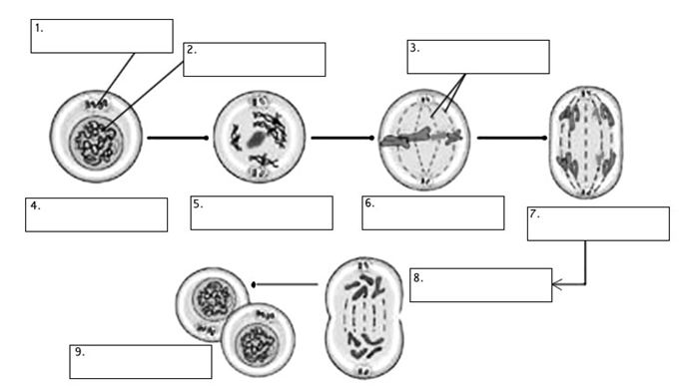
- Look at problems below and decide if they represent mitosis or meiosis. Then circle the correct word (mitosis or meiosis).
    - Happens in Body Cells Mitosis or Meiosis?

    - Happens in Sex Cells Mitosis or Meiosis?

    - Results on 4 new cells Mitosis or Meiosis?

    - Results in 2 new cells Mitosis or Meiosis?

    - Helps increase genetic variation
(how different or alike organisms are) Mitosis or Meiosis?

    - Used in growth/development Mitosis or Meiosis?

L.L.2.2 Infer patterns of heredity using information from Punnett squares and pedigree analysis.
SS Assessment Results:
Genotype:
Phenotype:
Allele:
Dominant:
Recessive:
Homozygous:
Heterozygous:
Punnett Squares and Pedigree Practice:
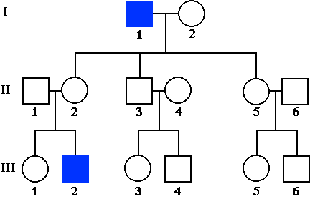
7.L.2.3 Explain the impact of the environment and lifestyle choices on biological inheritance (to include common genetic diseases) and survival.
Genetic Disease:
- Inherited:

- Tendency:

- Environmental:
Environmental Stressors:
Selective Breeding:

Unit 4: Forces and Motion
7.P.1.1 Explain how the motion of an object can be described by its position, direction of motion, and speed with respect to some other object.
Motion:
SS Assessment Results:
Reference Point:
Speed:
Position:
Velocity:
7.P.1.2 Explain the effects of balanced and unbalanced forces acting on an object (including friction, gravity and magnets).
SS Assessment Results:
Balanced Force:
Unbalanced Force:
Friction:
Gravity:
Inertia:
What is Newton’s First Law? Give an Example of Newton’s First Law.

What is Newton’s Second Law? Give an Example of Newton’s Second Law.

What is Newton’s Third Law? Give an Example of Newton’s Third Law.

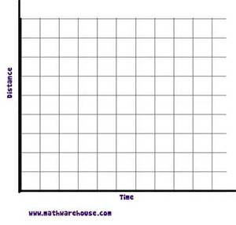
7.P.1.3 Illustrate the motion of an object using a graph to show a change in position over a period of time; and 7.P.1.4 Interpret distance versus time graphs for constant speed and variable motion.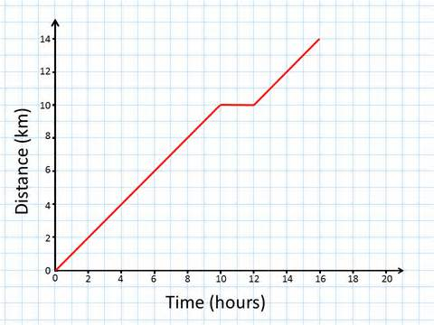 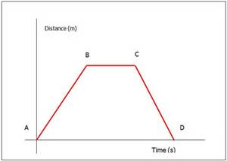
SS Assessment Results:

Helpful Hints:
Line is rising:
Line is flat:
Line is falling:
The steeper the line the ______________________ the object is __________________________________.
7.P.2.1 Explain how kinetic and potential energy contribute to the mechanical energy of an object; and 7.P.2.2 Explain how energy can be transformed from one form to another (specifically potential energy and kinetic energy) using a model or diagram of a moving object (roller coaster, pendulum, or cars on ramps as examples).
SS Assessment Results:
Label where PE and KE are occurring on each of the following diagrams:
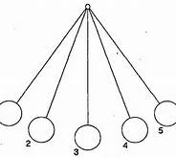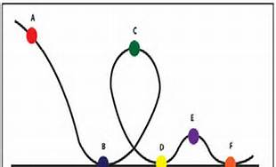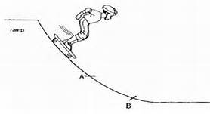
7.P.2.3 Recognize that energy can be transferred from one system to another when two objects push or pull on each other over a distance (work) and electrical circuits require a complete loop through which an electrical current can pass.
Thermal Energy:
Mechanical Energy:
Electrical Energy:
SS Assessment Results:
Electromagnetic Energy:
Examples of Energy Transfer:
What two factors must occur for WORK to take place?
Sketch a Parallel Circuit and a Series Circuit: What is the big difference in the two types of circuits?

7.P.2.4 Explain how simple machines such as inclined planes, pulleys, levers and wheel and axels are used to create mechanical advantage and increase efficiency.
SS Assessment Results:
Work:
Mechanical Advantage:
Pulley:
Inclined Plane:
Screw:
Wheel and Axle:
Lever:
 | Unit | Formula
Distance | cm, m, km
Time | s, min, hr
Mass | g, kg
Speed | m/s, km/hr | s=d/t
Velocity | Speed + direction | v= d/t + direction
Acceleration | m/s2 | a=v/t*
Force | Newton | F=ma
Work | Joule | W=F x d

