**Reducing our Carbon Footprint**

|  |  |  |
| --- | --- | --- |
| **Solution** | **Why will this help?** | **Problems?** |
| **Drive Less** |  |  |
| **Eat Locally** |  |  |
| **Drive a Hybrid** |  |  |
| **Use re-usable bags/bottles** |  |  |
| **Recycle** |  |  |
| **Water Conservation** |  |  |
| **Conserve Energy** |  |  |

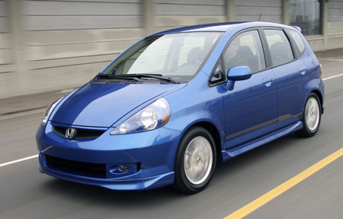

Photo: Carpooling! Photo: A Honda Fit

Solution: Drive Less/Fly Less-Walk and bike more!

Cars and planes are two of the most common contributors to global warming. Their exhaust pumps tons of CO2 and other harmful chemicals into the atmosphere. The contrails of airplanes (the white streams of vapor behind an airplane) trap a lot of heat in the atmosphere. This causes global warming.

What can I do?:

If you must drive, here are ways to make sure that your car is less damaging to the environment and better on gas:

1. Make sure your tires are properly inflated (or filled it air). It can save you 1 tank of gas per year and make your car more fuel efficient (you can get a few more miles out of any gallon of gasoline).

2. Trade your car in for a more fuel efficient car. The most fuel efficient cars on the market these days are usually smaller cars. For example: The Honda Fit or Toyota Yaris. Many new cars get better gas mileage than older cars, too.

3. Try not to start and stop your cars suddenly. Aggressive drivers can increase their fuel consumption by 33%. You can save gas and the environment by driving more smoothly.

Carpool with friends to school or the mall, ride your bike, take the train rather than fly (it’s sometimes cheaper too!), make sure that your parent’s car is properly tuned up and that the tires have enough air in them!

Interesting facts:

-If 1 million drivers stayed parked for just 1 day, 20,000 tons of CO2 emissions would be eliminated!

-If your car is going to be idling (sitting at a stop light turned on) for more than 10 seconds, it wastes less gas and produces less CO2 to turn off your engine and turn it back on again, than it does to let it run.

-If one million passengers decided to skip one 5 hour flight, 1 million tons of CO2 would be removed from the atmosphere.

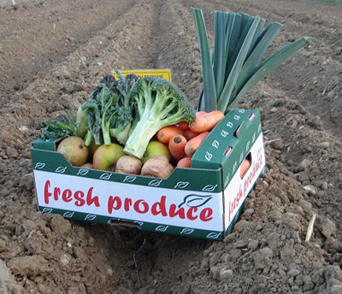

Solution: Eating Locally

* Food that is grown in other states or countries has to be flown or driven to Arizona grocery stores. This shipping releases carbon dioxide (CO2) and other fossil fuels (coal, gasoline) into the air. This causes global warming.
* Eating locally means that you buy things that are made or grown close by. This way, less carbon dioxide is released to get the food to you, the food is fresher and it supports farmers in your community. Arizona produces a variety of meat, dairy products, citrus fruits and vegetables including potatoes, corn and lettuce.

How can you do it:

Next time that you are at the grocery store, check the labels on your food to see where it was made or grown. Try to buy food that is grown in Arizona or in a state close to Arizona. Other ways to eat locally are to buy your produce from farmer’s markets or grow your own fruits and vegetables.

You can also buy less packaged food. Most food that is pre-packaged contains lots of cardboard, plastic, and other materials. For examples, buy cookies right from the bakery at the store instead of getting a box of Oreos. The cookies from the bakery were made right in Arizona, but the Oreos probably traveled thousands of miles.

Interesting Facts about your food:

* To reach your plate, a typical meal travels 22,000 miles!
* If one million people switched to locally grown food for just one year, we’d eliminate up to 625,000 tons of CO2

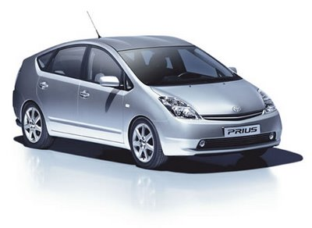

Photo: A Toyota Prius

Solution: Driving a Hybrid Car

There are many new types of cars that are being designed, which run on materials other than gasoline, which is a fossil fuel. Burning fossil fuels releases CO2 in to the air and directly causes global warming.

The most common alternative fuel sources are:

1. Biodiesel-a fuel made of new or used vegetable oils and animal fats (French fry grease, for example). It is biodegradable and uses leftovers!

2. Electricity- great short distance trips. Cars are charged like a battery from a and they don’t produce any exhaust or black smoke from their tail pipes.

3. Ethanol-a fuel that is created from plant-based materials, especially corn. Ethanol fuels are currently being added to regular gasoline. This helps reduce the harmful emissions from cars (smog and smoke from the tailpipe!)

4. Hydrogen – Hydrogen, like oxygen is a gas in our atmosphere. When you hear H2O, you’re actually talking about hydrogen and oxygen bonded (or stuck) together to make water. Hydrogen is a colorless, odorless gas and scientists believe they can make cars to run off of it. This would cause almost no pollution to come from cars.

**What can you do**?

Unfortunately, these special cars are pretty pricey! If you can afford it, it is possible to make your own car run off of special biodiesel fuels. Also, you could purchase a hybrid car, which gets half of its energy from gasoline, and have from electricity! This can save you money and the health of the environment, in the long run.

**Interesting facts:**

Hybrid cars average 62.9 miles of gasoline per gallon. Regular cars average about 20.

If everyone in America owned a hybrid car, the amount of CO2 and pollution emissions would drop from 300 million tons to 150 million tons. That’s HALF!

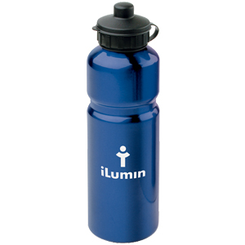

Photo: a metal water bottle

Solution: Using re-usable water bottles and bags

Plastic bags and bottle take up the most room in our landfills. Only about 1% of plastic bags get recycled, and it takes over 12 million barrels of oil to produce 500 billion plastic bags each year! Paper bags aren’t much better, since it takes millions of trees to create paper bags, only 20% of which get recycled. Using oil and cutting down trees both add to the problem of global warming.

**What can you do?**

Reuse your plastic bags around the house or recycle them at your local grocery store. You can also bring your plastic bags back to the store for a discount, to carry your food again. Lastly, you can purchase a cloth bag or a heavy-duty plastic bag that can be used again and again to carry your groceries.

To reduce your plastic bottle use, you can purchase a metal water bottle or a PCB-free plastic water bottle (PCB is a chemical in plastic that has been linked to increased cancer rates when it leaks into water sitting in a water bottle).

One downside is that sometimes cloth bags or metal water bottles can be expensive. However, if you use it over and over again it pays for itself and you help save the environment by using less plastic.

Interesting Fact:

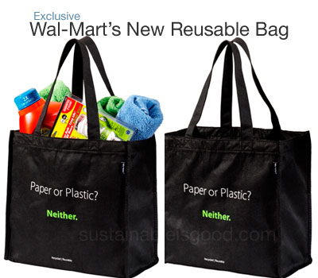-If 1 million people switched to reusable bags, we would eliminate the need for 1 billion plastic bags!



Solution: Recycling

Many of the products we use every day do not have to be thrown into dumps and landfills. Everything from your old sneakers to a plastic bottle can be recycled or reused in some way. It takes less energy to recycle a product than to make a new one. Using less energy means that there are fewer fossil fuels burned. As you know, that creates more CO2. This is how not recycling enough can make global warming worse.

**What you can do:**

Recycling can happen to more than just metal, glass, and paper. You can recycle or donate your old clothing, cell phones, computers and other electronics, batteries, timber (or wood).

Look for recycling bins near school or when you go out shopping. There are also large recycling centers, including one on Grand Avenue and Indian School Road.

**Interesting Facts:**

Recycling one aluminum can saves enough energy to run a TV for three hours -- or the equivalent of a half a gallon of gasoline.

If every American recycled just one-tenth of their newspapers, we would save about 25,000,000 trees a year.

A typical family consumes 182 gallons of soda, 29 gallons of juice, 104 gallons of milk, and 26 gallons of bottled water a year. That's a lot of containers -- make sure they're recycled!



**Solution: Water Conservation**

With all of the water on earth, did you know that only 1% is good enough for drinking? This is all the more reason to keep our drinking water clean and free from pollution. However, do you know how water gets into our homes? Water companies use lots of electricity to deliver water into your sinks and showers, which can create lots of CO2. This is how using too much water can make the problem of global warming worse.

**What you can do:**

To help save water, there are several things you can do. First, is to simply turn off the faucet when you are brushing your teeth and take shorter showers.

Another thing you can do is make sure all of the water faucets in your house are fixed. A leaky faucet can waste up to 100 gallons of water in a day. You can also flush your toilet less. Every flush wastes 6 gallons of water.

Make sure you run a washing machine or dishwasher only when it is completely full. Don’t waste the water by cleaning only half of what you could fit in there. Also, if you wash by hand, turn off the faucet. Use a bucket to hold soapy water and dunk your dishes!

**Interesting Facts:**

Pumping 700 gallons of water anywhere makes 5 pounds of CO2.

Every day, people use about 1800 gallons of water.

Showering and bathing use up the most percentage (27%) of water than anything else.

**Solution: Conserving Electricity**

The United States and other countries are using electricity 24 hours a day, seven days a week. We use electricity for things all the time: lighting our homes, transportation, cooking, heating and cooling our homes, and running appliances.

This picture of a house shows you what percentage of energy is used for in our homes.  How does using so much electricity contribute to global warming? Most of our electricity comes from power plants that run on coal. As we know, coal is a fossil fuel so burning it releases CO2 into the atmosphere.

**What you can Do**

Shutting things off when you aren’t using them is a good start, but did you know that even when appliances like your toaster are plugged in, they are still taking electricity from the socket? Instead, completely unplug things when you are not using them! This can include things like your tv, stereo, computer, lamps, or things in your kitchen.

Buy special energy-efficient light bulbs like the one pictured here. They save WAY more energy than regular light bulbs. In fact, if every American replaced ONE regular bulb with a energy-efficient one, we would save enough energy to light up 3 million homes. These bulbs can be found at any grocery store, Walmart, or hardware store!

Another thing you can do is buy newer energy-smart appliances, refrigerators, and heating and cooling systems. These are designed to do the same job as your old stuff, but they use less energy.

**Interesting Facts:**

Conserving electricity also means you and your family pay less each month on the electric bill! Save some cash and stop global warming at the same time.

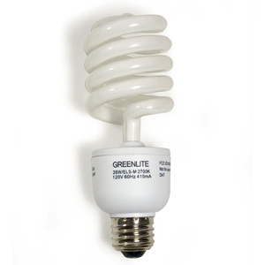$13 billion worth of wasted energy leaks out of homes through cracks and tiny holes every single year.  That would equal at least $150 per family.