Organelle Tip Sheet:
Cell Membrane:
  - Outer ____________________ of _______________________.
  - _________________________ the ________________________
  - Controls what _______________________ and _________________________ the cell
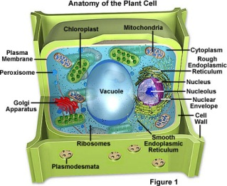
Cell Wall:
- Only found in _____________________________ cells
- Adds __________________________ and _________________________________________
- Made of ____________________________________________________.
- Allows __________________ and dissolved______________________________ to pass through.
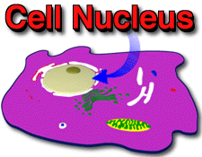
Nucleus:
- Controls most _____________________________ in the cell
- Contains all _________________________ information in the form of ______________.

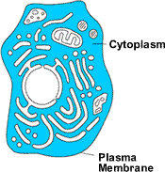
Cytoplasm:
- Clear __________________________ within cell that contains all ______________________
- Moves ________________________ throughout the ___________________________
Mitochondria:
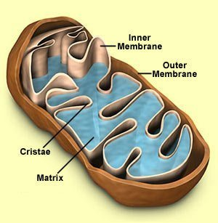
- _____________________________ producers
- _________________ of the _______________________
- Sausage-shaped
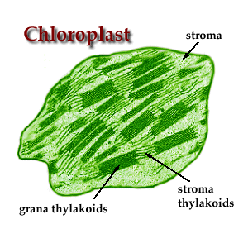
Chloroplasts:
- Only found in _________________________________
- Contain food or pigments
- Chloroplasts contain the pigment ______________________
Vacuoles:
- Store _____________, ___________________, or _______________________ materials
- ________________ cells have ___________________ vacuoles

