Name: ____________________
Date: _________________

Convection in the Atmosphere

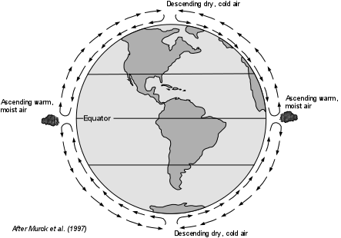

How does density change with temperature?
Part One

Did you know that air molecules can move close together or far apart depending on the temperature? Here’s how it works!

- Take your dry, room temperature balloon. Wrap a string around it and then measure the string to get a circumference of the balloon. Write your number here: ___________cm

- Take your balloon and submerge it into the ice bath. Wait for 10 seconds. Quickly take your balloon out and measure the circumference in the same way as you did in step number 1. Write your number here: ____________ cm

- Repeat step number 2 but leave the balloon in the ice bath for 30 seconds. Take out your balloon and measure the circumference. Write your number here: ____________ cm

- What is happening to the air molecules in the balloon to cause it to shrink?

Hot air rises, cold air sinks. Remember this! You will have to put this knowledge, together with the activity below, to make a conclusion later.

Density: Does it sink or does it float?
Part Two

At your station there is a bottle with several layers in it. Don’t shake up the bottle yet!! The layers, starting at the top, are the following:

1 –

2 –

3 –

4 –

If I told you that something with a higher density sinks, write “high density” next to the layer with the highest density. Write “low density” next to the layer with the lowest density.

Make a prediction: What do you think is going to happen when you mix these layers together? ____________________________________________________________________________________________

Gently invert the bottle so that the layers are mixed together.

What happened? __________________________________________________________________________

Where in real life have you seen this happen? _______________________________________________

If something is more dense does it sink or float? ____________________________

If something is less dense does it sink or float? _____________________________

Conclusion

This is where we will put it all together. Let’s recap. You have learned how temperature affects density. You have learned how density affects if something sinks or floats. Now answer the questions below using your newly acquired knowledge and the diagram below.

- Where on the diagram does it show Earth’s temperature as being the hottest?

- Where on the diagram does it show Earth’s temperature as being the lowest?

- Why is the air at the equator rising? (Hint: think about density)

- Why is the air at the poles sinking?

- What do you think this means for weather patterns around the world?

