Class Work: Fly me to the Moon
Instructions: 9.8 m/s² only applies to the gravity of Earth. Each of the planets or moons in the solar system has a different gravity. Your traditional weight is in pounds, Find your new weight (in Newtons) if you were to travel to different planets.
- Before you do: My “weight” (lbs or pounds ) is __________
Multiply by 0.45 to get kg (mass) ____________
Planet/Moon |  | Gravity | Weight (work out below)
I DO: Earth | 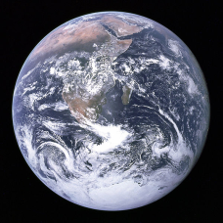 | g = 9.8 m/s2
WE Do: Pluto (not a planet anymore ) | 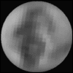 | g = 0.62 m/s²
YOU DO: Mercury | 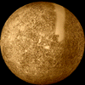 | g = 3.7 m/s²
Venus | 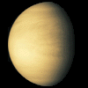 | g = 8.90 m/s²
Jupiter | 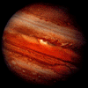 | g = 23.17 m/s²

- Nicki Minaj is scouting out locations for her new music video entitled “I’m really very talented but also really crazy” and she wants to figure out what the acceleration due to gravity (g) is on each planet. If Nicki Minaj weight 490 N on Earth, figure out the gravity on the following planets:
Plane |  | Mass | Gravity (work out below) | Weight
I DO: Earth |  |  | g = 9.8 | 490 N
WE Do: Mars | 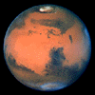 |  |  | 185 N
YOU DO: Saturn | 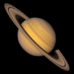 |  |  | 450 N
Uranus |  |  |  | 433.5 N
Neptune | 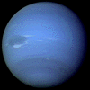 |  |  | 550 N

- The title of this worksheet comes from Frank Sinatra’s song “Fly me to the moon.” Let’s say Frank wanted to take a trip to the sun instead. On the Sun, Frank’s weight was 22,000 N. If the sun has a whopping 275 m/s² acceleration due to gravity, what is ol’ blue eyes (nickname for Sinatra) actual mass?

