**Station ONE:**

**Determining speed using the Time vs. Distance Graph**

**10**

|  |  |  |  |  |  |  |  |  |  |
| --- | --- | --- | --- | --- | --- | --- | --- | --- | --- |
| **9** |  |  |  |  |  |  |  |  |  |
| **8** |  |  |  |  |  |  |  |  |  |
| **7**  Distance (meters) |  |  |  |  |  |  |  |  |  |
| **6** |  |  |  |  |  |  |  |  |  |
| **5** |  |  |  |  |  |  |  |  |  |
| **4** |  |  |  |  |  |  |  |  |  |
| **3** |  |  |  |  |  |  |  |  |  |
| **2** |  |  |  |  |  |  |  |  |  |
| **1** |  |  |  |  |  |  |  |  |  |
|  |  |  |  |  |  |  |  |  |  |

1 2 3 4 5 6 7 8 9 10

Time (seconds)

***Calculate the average speed of the car each point below.***

***Sample:***

***Point A***

1. Find the point on the line.
2. Record the coordinates.

* Distance=
* Time =

1. Find the speed using the formula S= D/T

*The average speed of the car is ______________m/s at point A.*

**1. Point B**

**2. Point C**

**3. Point D**

**Station 2**

**Jabriel and Kaden were meeting at the movies. They decided that whoever got there first would buy the tickets. Jabriel was on his skateboard and Kaden used his rollerblades. Use the information in the chart below to graph Jabriel and Kaden’s trip to the movies.**

|  |  |  |
| --- | --- | --- |
| **Time (min)** | **Jabriel’s Distance (yards)** | **Kaden’s Distance (yards)** |
| 0 | 0 | 0 |
| 2 | 5 | 10 |
| 4 | 10 | 20 |
| 6 | 20 | 20 |
| 8 | 30 | 35 |
| 10 | 45 | 40 |
| 12 | 50 | 55 |

|  |  |  |  |  |  |  |
| --- | --- | --- | --- | --- | --- | --- |
|  |  |  |  |  |  |  |
|  |  |  |  |  |  |  |
|  |  |  |  |  |  |  |
|  |  |  |  |  |  |  |
|  |  |  |  |  |  |  |
|  |  |  |  |  |  |  |
|  |  |  |  |  |  |  |

**Station Three:**

**Answer these problems**

1. 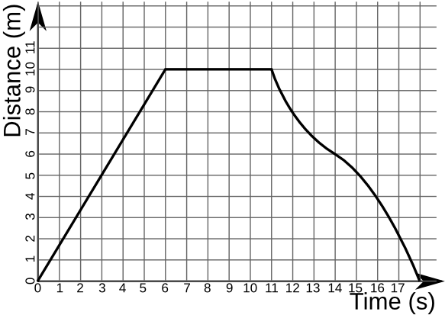 What is a true statement about the motion of the car at **point B** in the graph to the right?

A) The car is accelerating.

B) The car is stopped.

C) The car is decelerating.

D) The car is moving at a constant speed.

2.

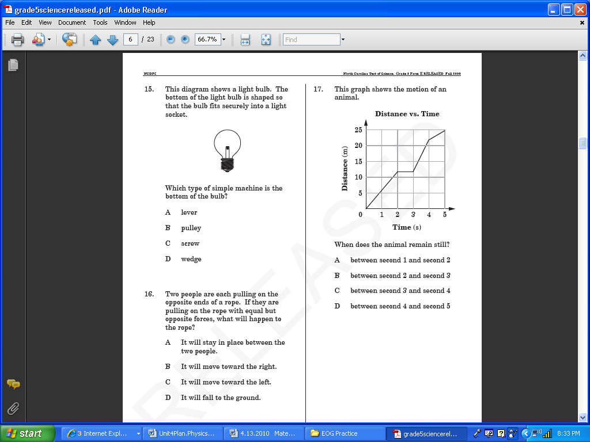

3. Which graph (A, B, C or D) best shows the motion of a basketball being shot and rebounded? _______

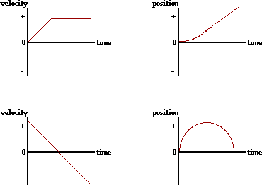4. Which graph (A, B, C or D) best shows a car speeding up then traveling at the speed limit? __________

5. Which graph (A, B, C or D) best shows a cheetah continuously moving far from its home? __________

6. Which graph (A, B, C or D) best shows an object slowing down and going backwards? ____________

**Station Four:**

**Aliyah was walking home from dance practice. She wanted to make it there before her favorite show, Empire, came on. Create a graph of Aliyah’s trip home.**

|  |  |
| --- | --- |
| **Time (minutes)** | **Distance (meters)** |
| 0 | 0 |
| 1 | 20 |
| 2 | 50 |
| 3 | 80 |
| 4 | 110 |
| 5 | 120 |
| 6 | 120 |

|  |  |  |  |  |  |  |
| --- | --- | --- | --- | --- | --- | --- |
|  |  |  |  |  |  |  |
|  |  |  |  |  |  |  |
|  |  |  |  |  |  |  |
|  |  |  |  |  |  |  |
|  |  |  |  |  |  |  |
|  |  |  |  |  |  |  |
|  |  |  |  |  |  |  |

**Station Five:**

1. 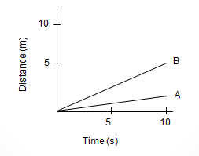**Which is faster car A or Car B? How do you know? (You must use the words *SLOPE, DISTANCE, and TIME* in your response.**
2. 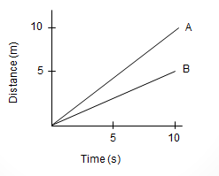**Which is faster car A or Car B? How do you know? (You must use the words *SLOPE, DISTANCE, and TIME* in your response.**
3. **What is happening to the SPEED of the object? How do you know?**



**Station Six**

**Ms. Gilbert and Mr. Melnik are taking their service group on a field trip after school. They decided to keep track of the miles they traveled each minute.**

|  |  |
| --- | --- |
| **Time (minutes)** | **Total Distance from Start (miles)** |
| 0 | 0 |
| 1 | 2 |
| 2 | 0 |
| 3 | 0 |
| 4 | 3 |
| 5 | 6 |
| 6 | 9 |
| 7 | 9 |
| 8 | 9 |
| 9 | 10 |
| 10 | 11 |

**Station Seven:**

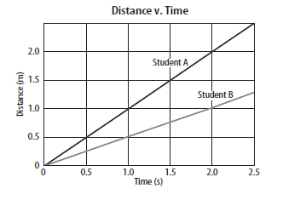

1. **How long did it take Student A to travel 1.5 m?**
2. **How far did Student B travel in 2 s?**
3. **What is Student A’s speed? (Show all work)**
4. **Who was faster? How do you know?**

**Station Eight:**

1. **What is happening to the POSITION of the object? How did the object move in relation to their starting point? How do you know?**



1. **What is happening to the POSITION of the object? How did the object move in relation to their starting point? How do you know?**



1. **What is the speed of the graph in question #3? Show all of your work.**

Name ________________________________________________________________

**INDEPENDENT PRACTICE SHEET**

**Adreanna was walking home from the movies with Mohamad and Erica. Create a graph of the distance they walked to get home and answer the questions that follow.**

|  |  |
| --- | --- |
| Time (minutes) | Distance (meters) |
| 0 | 0 |
| 1 | 20 |
| 2 | 50 |
| 3 | 80 |
| 4 | 110 |
| 5 | 120 |
| 6 | 120 |

|  |  |  |  |  |  |  |
| --- | --- | --- | --- | --- | --- | --- |
|  |  |  |  |  |  |  |
|  |  |  |  |  |  |  |
|  |  |  |  |  |  |  |
|  |  |  |  |  |  |  |
|  |  |  |  |  |  |  |
|  |  |  |  |  |  |  |
|  |  |  |  |  |  |  |

**Once you have drawn your graph use it to answer the following questions below.**

1. **How far did Adreanna, Mohamad, and Erica travel? ____________________**

**How long did their walk take? _______________________**

1. **Calculate their average speed from *2 seconds to 3 seconds*. Show your work below and box your answer.**
2. **What is the average speed of the ENTIRE walk? Show your work below and box your answer.**
3. **After looking at the data, what can you conclude about where the 3 students were during the last 2 minutes?**
4. **Did the scholars stop to rest at any point? How do you know?**