Name ______________________________________________ Block__________________________________________
Distance-Time Graph Stations
Station 1: (SHOW YOUR WORK!)

9
8
7
Distance (meters)
6
5
4
3
2
1
1 2 3 4 5 6 7 8 9 10
Time (seconds)
1. Point B

2. Point C

3. Point D
Station 2:

Station 3:

1.
2.
3.
4.
5.
6.

Station 4:

Station 5:
1.

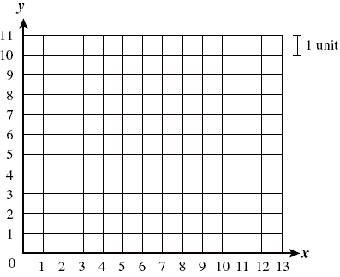2.

3.

Station 6:

Station 7:
1.

2.

3.

4.

Station 8:
1.

2.

3.

Exit Ticket:
Adreanna was walking home from the movies with Mohamad and Erica. Create a graph of the distance they walked to get home and answer the questions that follow.

Time (minutes) | Distance (meters)
0 | 0
1 | 20
2 | 50
3 | 80
4 | 110
5 | 120
6 | 120

Once you have drawn your graph use it to answer the following questions below.
- How far did Adreanna, Mohamad, and Erica travel? ____________________
How long did their walk take? _______________________
- Calculate their average speed from 2 seconds to 3 seconds. Show your work below and box your answer.

- What is the average speed of the ENTIRE walk? Show your work below and box your answer.

- After looking at the data, what can you conclude about where the 3 students were during the last 2 minutes?

- Did the students stop to rest at any point? How do you know?

