Name:
Study Guide: Cells
Vocabulary:
Structure:
Function:
Cell Theory:
Unicellular:
Multicellular:
Prokaryotes
Eukaryotes:
Cell Membrane:
Nucleus:
Nuclear Membrane:
Cytoplasm:
Mitochondria:
Vacuoles:
Cell Wall:
Chloroplasts:
Cell:
Tissue:
Organ:
System:
Organism:
Protists:

For the test, you should be able to:
- List and describe the characteristics of life.
- Explain Cell Theory.
- Distinguish between prokaryotic and eukaryotic organisms.
- Describe the structure and function of each cell organelle.

        - Cell Membrane
        - Cell Wall
        - Nucleus
        - Nuclear Membrane
        - Chloroplasts
        - Mitochondria
        - Vacuole
        - Cytoplasm

- Identify the relationship between cell organelles. (See above).
- Identify, compare, and contrast animal and plant cells.
- Discuss characteristics of unicellular organisms.
- Identify an Amoeba.
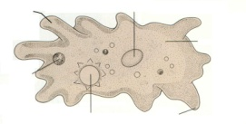
  - Describe characteristics, its movement, and its nutrition.
- Identify a Paramecium.
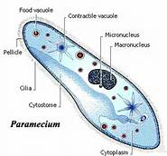
  - Describe characteristics, its movement, and its nutrition.
- Identify a Euglena.
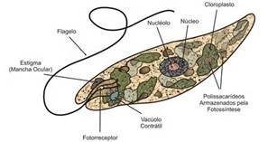
  - Describe characteristics, its movement, and its nutrition.
- Identify a Volvox.
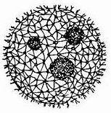
  - Describe characteristics, its movement, and its nutrition.
- Explain the organization of multicellular organisms
  - (celltissueorganorgan systemsorganism)

