Name: _________________________
Date: __________________

Graphing the Atmosphere

Directions: The graph below shows how temperature changes with the altitude of the atmosphere. Each layer is labeled in the center. The temperature is labeled at the top (in F) and the bottom (in C). The altitude/height is labeled on the sides. Use the information in the graph to answer the questions below.
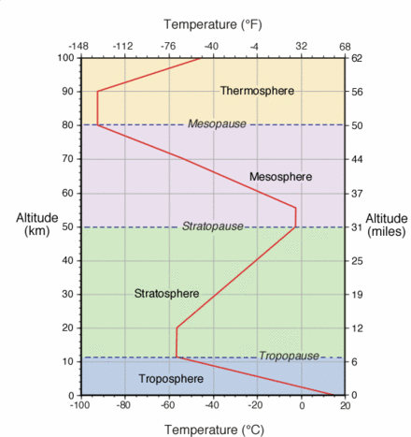

- At an altitude of 40 km, which layer of the atmosphere would you be in?

- What is the approximate temperature where the troposphere meets the stratosphere?

- What is the range of temperatures you would find in the mesosphere?

- What is the altitude range for each layer?
  - Troposphere -
  - Stratosphere -
  - Mesosphere –

- Make a Prediction: This graph does not include temperatures of the entire thermosphere. Based on the graph, what do you think the temperature would be at an altitude of 110 km?

